Title of Abstract

Name First author¹, Name Coauthor² and Name Other Coauthors²
¹ Institution, Street, City, Country, ²Institution, Street, City, Country
E-mail: corresponding.author@domain.com

This is the template of the abstract for “Book of Abstracts for INF Khajuraho 2026”. The abstract must be written in English and should report original work. The total length is one A4 format page, including figures/tables and references, summarizing the presentation. The submitted file must be Microsoft Word 2010 or newer versions. A PDF file is not acceptable. Margins are 3.5 cm for top, 3.0 cm for left and right. The font should be Helvetica.
The title should be no longer than two lines. Avoid unusual abbreviations. Center the title (12 point bold), authors’ names (10.5 point bold), affiliations (10.5 point italic) and the e-mail address of corresponding author (10.5 point bold italic). The name of presenting author should be underlined.
Leave one blank line (10.5 point) after the title, one blank line (10.5 point) after the authors’ names and affiliations. Leave two blank lines (10.5 point) between e-mail address of corresponding author and the beginning of the paper.
Body text should be left and right justified. Start a new paragraph by indenting from the left margin by 5 mm.
List and number all references at the end of the abstracts. When referring them in the text, type the corresponding reference number between brackets as shown here [1].

References
[1] A. Yamada, J. Tribophys., 1 (2011) 11.
[2] B, Tanaka, J. Tribochem., 2 (2022) 22.

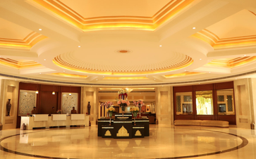
Fig. 1 Foyer, Hotel Chandela, Khajuraho

